Assignment 2

Cloud server project

Safeer Ullah Khan

35456363

**Global IP address: 172.164.241.73**

**Domain name server:** [**https://safifootball.com**](https://safifootball.com)

**Git hub:**

Contents

setting up the Web Server:……………………………………….. 3

setting up website:…………………………………………………… 5

Linking with domain name server:…………………………….. 6

SSL/TLS Documentation:…………………………………………. 7

Reference:……………………………………………………………….. 9

Setting up a web server

1. Open Azure, create a virtual machine, and connect it to your Ubuntu :

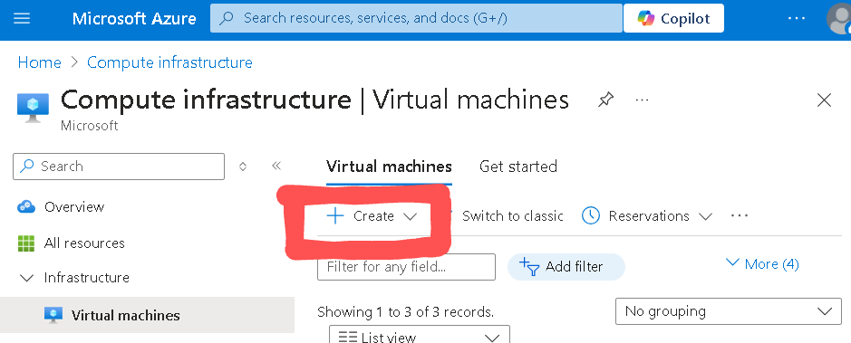

1. Connect via SSH

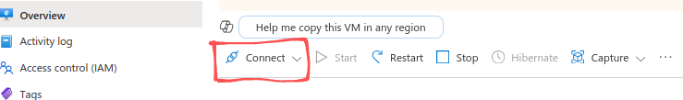

1. Put in the private key and copy the commands

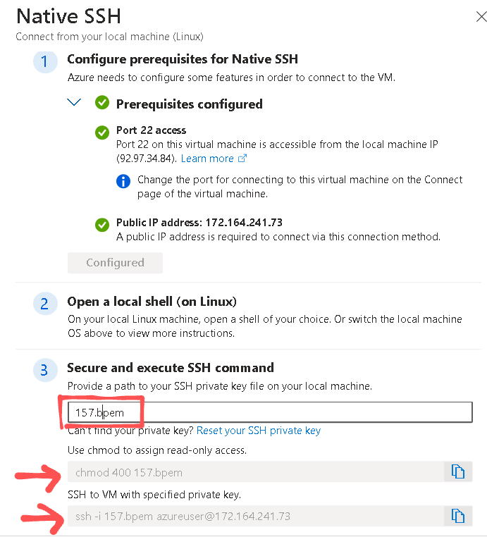

1. Paste the commands in to the terminal



1. Update and upgrade

Sudo apt update

Sudo apt upgrade

1. Install Apache on Ubuntu

Sudo apt install apache2

1. Go to firefox and type ‘localhost’:

A page like this should appear:

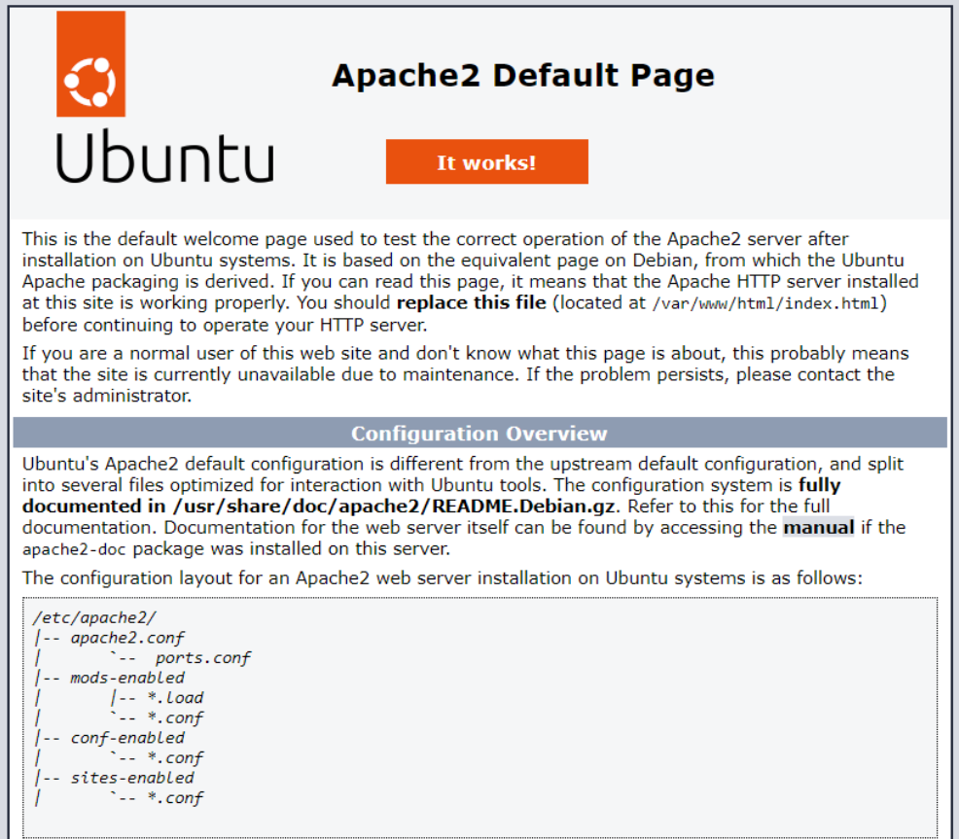

**Setting up website**

1. Changing the page content:

cd /var/www/html

Ls

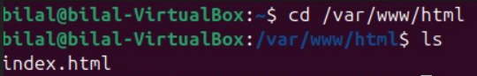

1. Edit the content of the index.html file, and put in your html code that you want for your website.

Sudo nano index.html

Ctrl+o # to save file

Ctrl+x # to exit file

1. create CSS file for index.html write the CSS code for your website

Ctrl+o # to save file

Ctrl+x # to exit file

sudo touch styles.css

1. make sure that index.html file is pointed towards your CSS file



1. Create a JavaScript file and write JavaScript code.

Sudo nano script.js

Ctrl+o # to save file

Ctrl+x # to exit file

1. Now, when you copy the public IP address of your virtual machine and paste it into your Firefox or any other search engine, you should be able to see your website.

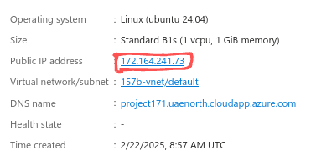



**Linking with DNS**

1. Check if port 80 is enabled

Sudo ufw status

If not enabled then

Sudo ufw allow port 80/tcp

Sudo ufw enable

Generally when you are creating your virtual machine you can activate port 80 with the ssh port.

1. Go to your domain provider, for me it is ‘Go Daddy’ and create ‘A’ record and put in your ip address in it so your domain can be directed towards your virtual machine.

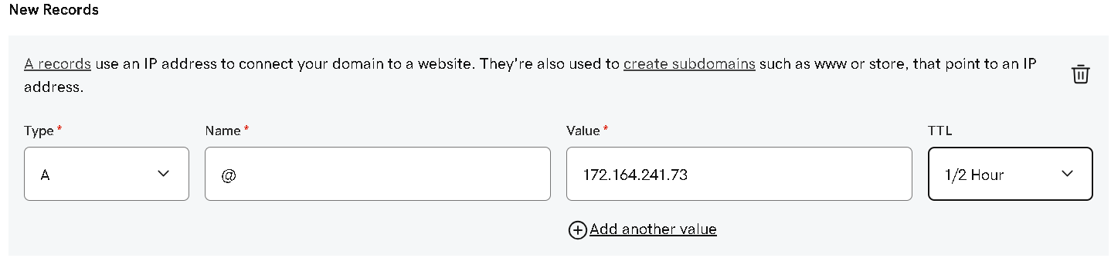

**SSL documentation**

1. Go to your Azure virtual machine VM>networking > networking settings. Check if the HTTPS port 443 is allowed.

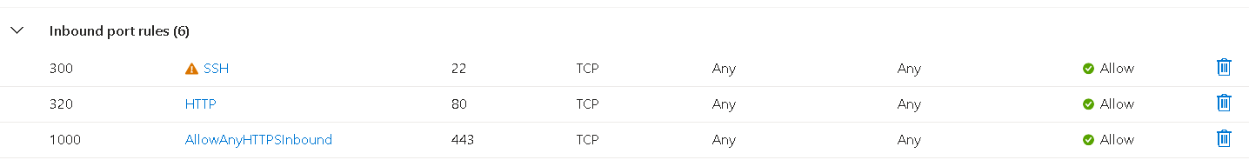

If the HTTPS 430 port is not allowed, create new port rules and make an HTTPS port available.

1. Now install cert bot, which is an encryption client

Sudo apt install certbot python3-certbot-apache

1. Install cerfictaes on your sever

Sudo certbot yourdomain.com www.yourdomain.com

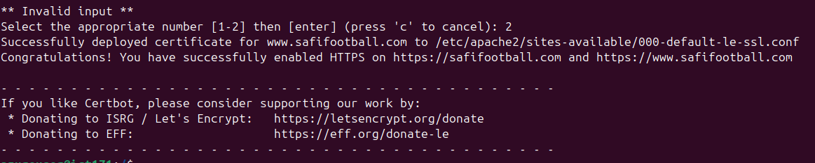

1. Now script for automatic renewal

Sudo nano /usr/local/bin/renew_ssl.sh

Now paste this commands into the file

#!/bin/bash

Certbot renew –quiet –post—hook “systemctl restart apache2”

Echo “SSL renewal attempted on $(date)” >> /var/log/ssl_renewal.log

Sudo chmod +x /usr/local/bin/renew_ssl.sh

1. Make the file executable

Now to automate it via cron

Sudo crontab -e

Add this line to the file ( renewal 3 am )

0 3 *** /usr/local/bin/renew_ssl.sh

Ctrl+o # to save file

Ctrl+x # to exit file

1. To verify SSL is working

Curl –I https://yourdomain.com

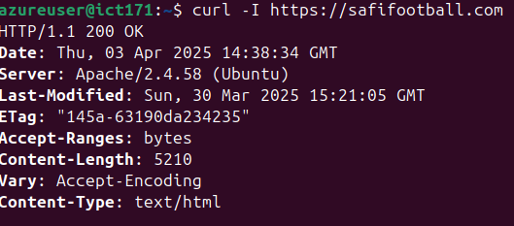

**Reference list**

Infrasity. (2022, October 8). *Azure Custom Domain and SSL Cert | Shantanu das* [Video]. YouTube. <https://www.youtube.com/watch?v=paMRstdOU00>